Team Overhead Journal

*Year 2 (2022-2023)*

| Name | Text Color |
| --- | --- |
| Nohami Zerihun (Sophomore) | Gray |
| Arham Siddiqui (Sophomore) | Red |
| Adam Hamadene | Orange |
| Aadi Shah | Green |
| Sireesha Dandamudi | Light blue |
| Grace Calfee | Blue |
| Rehaan Karnik (Sophomore) | Purple |
| Pranathi Ravipati | Pink |
| Hiranya Parekh (Sophomore) | Magenta |

## **20 May 2023 / Meeting Duration: 270 min, 8:00 - 12:30 PM**

ATTENDEES:

| Aadi | Adam | Arham | Grace | Hiranya | Pranathi | Rehaan | Sireesha |
| --- | --- | --- | --- | --- | --- | --- | --- |
| ✅ | ✅ | ✅ | ✅ | ✅ | ✅ | ✅ | ✅ |

AGENDA

* Presentation w/ Juniors & Sophomores
* Symposium Prep
* STEM Symposium

## 

## **08 April 2023 / Meeting Duration: 150 min, 10:00 - 12:30 PM**

ATTENDEES:

| Aadi | Adam | Arham | Grace | Hiranya | Pranathi | Rehaan | Sireesha |
| --- | --- | --- | --- | --- | --- | --- | --- |
| ✅ |  | ✅ | ✅ |  | ✅ |  | ✅ |

AGENDA

* Discuss and work on patent documentation
* Organize prototype models into drive
* Extra: design challenge

# Work Accomplished

* Worked on and edited patent document
* Obtained models for prototype
* Organized drive

Next Meeting’s Agenda

* Try to finish patent document
* Work on website and finalize content

## 

## **3 April 2023 / Meeting Duration: 90 min, 7:00 - 8:30 AM**

ATTENDEES:

| Aadi | Adam | Arham | Grace | Hiranya | Pranathi | Rehaan | Sireesha |
| --- | --- | --- | --- | --- | --- | --- | --- |
|  | ✅ | ✅ | ✅ |  | ✅ | ✅ | ✅ |

AGENDA

* Discuss symposium project
* Work on provisional patent document

# Work Accomplished

* Discussed symposium project (due date, workload, requirements)
* Worked on provisional patent document (goal due date: end of month)

Next Meeting’s Agenda

* Continue to work on provisional patent
* Solder broken wire

## 

## **2 April 2023 / Updates**

**Next steps:**

Plan for the Rest of the Year

* Work on getting a provisional patent (April)
* Continue creating iterations of prototype until Omar’s feedback is implemented (April: presenting prototype to cohort, work on prototype in May as well)
* Try to meet with Omar again (maybe-not sure about availability yet)
* Conduct research on how to gain non-profit status + feasibility (April-May)
* Continue to work on and possibly finish the website (April-May)

## **29 March 2023 / Meeting Duration: 75 min, 3:30 - 4:45 PM**

ATTENDEES:

| Aadi | Adam | Arham | Grace | Hiranya | Pranathi | Rehaan | Sireesha |
| --- | --- | --- | --- | --- | --- | --- | --- |
|  |  | ✅ | ✅ |  | ✅ |  |  |

AGENDA

* Patent Meeting

# Work Accomplished

* <https://ipidentifier.uspto.gov/#/identifier/welcome>
* Minimum amount of money for TEAS Plus is $250 for only one good/service
* Types of patents
  + Utility
  + Design
  + Plant
* In the U.S., there is a first-inventor-to-file system
* Takes a year or two for examiner to pick up your case
* Can do a patent search at uspto.gov or google patents
* Specific Group Notes
  + Consider filing a provisional patent or have an NDA for testers/during testing
    - Can use patent pending
    - Can have more power to disclose info for funding
    - Within 12 months, file non-provisional
    - Once you file, you can move forward with creation
      * Research if there is anything else similar out there
    - Talk to attorney about filing different patents for different aspects of the hat
    - Provisional patents are never published, just give you an extra 12 months
    - About $70 to file a provisional patent
  + Patent Information and notes:
  + <https://docs.google.com/document/d/1QK12FeosL5PsuIEOaDXMh0I8-bESWoMf3BA11nuyZRg/edit?usp=sharing>

Next Meeting’s Agenda

* Work on provisional patent template

## **25 March 2023 / Meeting Duration: 240 min, 8:30-12:30 AM/PM**

ATTENDEES:

| Aadi | Adam | Arham | Grace | Hiranya | Pranathi | Rehaan | Sireesha |
| --- | --- | --- | --- | --- | --- | --- | --- |
| ✅ | ✅ | ✅ | ✅ | ✅ | ✅ | ✅ | ✅ |

AGENDA

* Visit Omar
* Test Overhead Hat and receive feedback

# Work Accomplished

Areas of Improvement Notes

* Earpiece with CV for the purpose of object recognition for obstacle detection
  + Would this implement reinforcement learning? Would we use Keras/Tensorflow or just OpenCV?
  + At work, has to keep ears free due to number of noises he has to listen for (and he prefers keeping ears free)
  + Possibly use bone conduction earphones placed around his temples/___ bone
* Will adjust angles based on head position we see from him

Test Notes

* Left ultrasonic sensor going off at intermittent times
  + Possibly due to light? But ultrasonic sensors don’t detect light so that doesn’t really make sense.
  + Possibly due to faulty wiring
* Ultrasonic sensors have an interesting scope angle
  + Blind spot directly in front
  + Detects objects slightly off to side
  + Can detect thin branches directly in front, though
* May implement computer vision via CV
* Tried 60 cm distance, worked well
* Tried 90 cm distance, also worked well, Omar preferred it
  + Detected a bush slightly off to the side but Omar preferred it anyway
* Tried 120 cm distance, Omar stated it was a bit too much
* Tried 105 cm distance, worked well, although detected some more periphery objects
* Made some adjustments in distance from 1 feet to 3 feet
* Angle at which ultrasonic sensor is sending at a narrow angle

Angle is at 15 degrees, may increase angle slightly

Next Iteration is making the distance at 105 cm

Possibly implement bone conduction headphones for his audible cues

Next Meeting’s Agenda

* Fix the wires that broke
* Continue to work on hat
* Continue to work on website

## **13 March 2023 / Meeting Duration: 90 min, 7:00 - 8:30 AM**

ATTENDEES:

| Aadi | Adam | Arham | Grace | Hiranya | Pranathi | Rehaan | Sireesha |
| --- | --- | --- | --- | --- | --- | --- | --- |
|  | ✅ |  | ✅ |  | ✅ |  | ✅ |

AGENDA

* Update website
* Researching OpenCV

# Work Accomplished

* <https://community.element14.com/products/roadtest/b/blog/posts/ml-capability-of-raspberry-pi-zero-2w-face-detection-and-image-sorting-using-opencv>
* I think the amount of RAM for raspberry pi zero 2 W is 512 MB
* Added more posts and documentation for website on the process of our product

Next Meeting’s Agenda

* Prepare for meeting with Omar

## **09 March 2023 / Meeting Duration: 90 min, 7:00 - 8:30 AM**

ATTENDEES:

| Aadi | Adam | Arham | Grace | Hiranya | Pranathi | Rehaan | Sireesha |
| --- | --- | --- | --- | --- | --- | --- | --- |
|  | ✅ | ✅ | ✅ | ✅ | ✅ | ✅ | ✅ |

AGENDA

* Fix loose wires
* Update website
* Add a battery pack on the back of the hat
* If possible incorporate some testing, and develop testing procedures.
* Adding documentation for previous prototypes on website
  + Blog post format?
  + Convert website to development portal from blog post format?
  + Should we create logins/login info?

Work Accomplished

* Worked on the website
* Researched raspberry pi 2 w costs + stock

## **03/04 Progress Check**

Pranathi:

Since February 13, I have spent about 2 hours on the project. I worked on the website and sent an email to Ms. Spector to send to Omar about our progress and to set up a time to meet for him to try the improved hat. As a team, we are currently working on testing our device ourselves before testing it with Omar.

Aadi:

Since February 13, I have spent about 2 hours on the project. I spent most of that time on the website, fleshing out pages such as one outlining the details of the first iteration of our prototype, for documentation purposes (in an easy-to-read format). I started on similar pages discussing iterations after the first one but before our current one, and will flesh them out as we continue to work on the project. At the moment, the website is as much of a form of (visual) documentation for us as it will be informative for potential viewers, but we can always tweak it and hide certain information in the future. If we continue with our plan of going open-source or pursuing a patent/provisional patent, the confidentiality of this information may become less relevant.

Adam:

Since February 13, I have spent around 2 hours on the total project. I spent most of my time building the website with Aadi and really focused on building a general layout for what our view is for our domain. We have made steady progress in the website as we have finished drafting and will soon begin the final product for what our website will look like. We are in the stages of testing and have sent an email to Omar about possibilities to meet up with them and test the prototype.

Sireesha:

Since February 13, I have spent about 2 hours on the project. I worked on editing the website so that it contains descriptions of our project and initiative alongside my teammates, as well as researching ways on how to potentially become a nonprofit since Hackplus did not pan out. We are currently working on perfecting our prototype for Omar, and regarding future endeavors, are preparing to discuss how to obtain a patent.

## **13 February 2023 / Meeting Duration: 1.5 hours**

| Aadi | Adam | Arham | Grace | Hiranya | Pranathi | Rehaan | Sireesha |
| --- | --- | --- | --- | --- | --- | --- | --- |
| ✅ | ✅ | ✅ | ✅ | ✅ | ✅ | ✅ | ✅ |

Getting feedback for roadblocks:

Our product is a hat that can sense overhead objects using ultrasonic sensors and vibration motors, designed for our visually impaired community partner Omar, whose cane is unable to detect these objects.

Problem: The wires that we soldered to our vibration motors loosens, causing the device to not work properly. We keep fixing it, but it keeps falling apart.

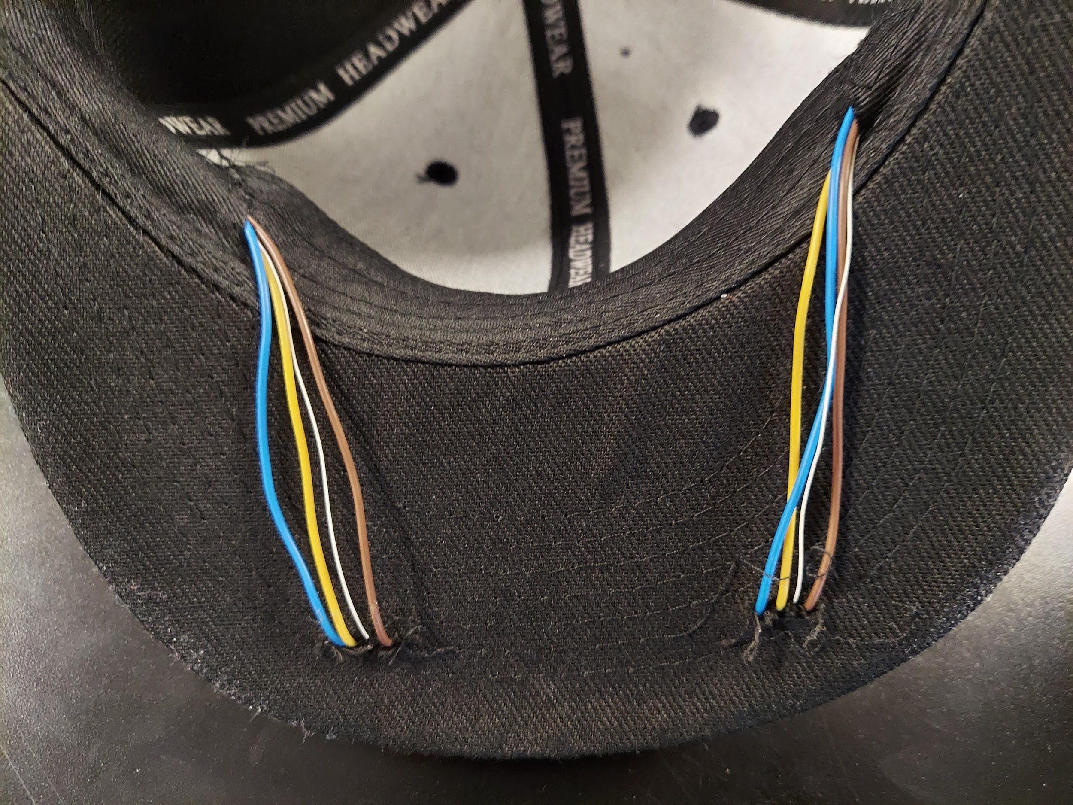

Question: How can we make sure our wiring does not continuously become loose in the hat?

## **09 February 2023 / Meeting Duration: 90 min, 7:00 - 8:30 AM**

ATTENDEES:

| Aadi | Adam | Arham | Grace | Hiranya | Pranathi | Rehaan | Sireesha |
| --- | --- | --- | --- | --- | --- | --- | --- |
|  |  | ✅ | ✅ | ✅ |  | ✅ |  |

AGENDA

* Fix faulty connections
  + Ground wire came unsoldered
* Create Testing Procedure for the Device
* Incorporate enclosure

# Work Accomplished

* Testing Procedure-Brief outline (detection time based on distance):
  + X-Axis: time
  + y-Axis: detection time for distance x, y, z
  + Record this using data from the serial monitor
  + Log x as time object is placed in front, Log y as seconds it takes to start vibrating
* Testing Procedure (vibration length based on object duration):
  + X-Axis: time
  + Y-Axis: vibration duration for motor a, b
  + Record this using data from the serial monitor
  + Log x as seconds object is placed in front, Log y as seconds motor vibrated

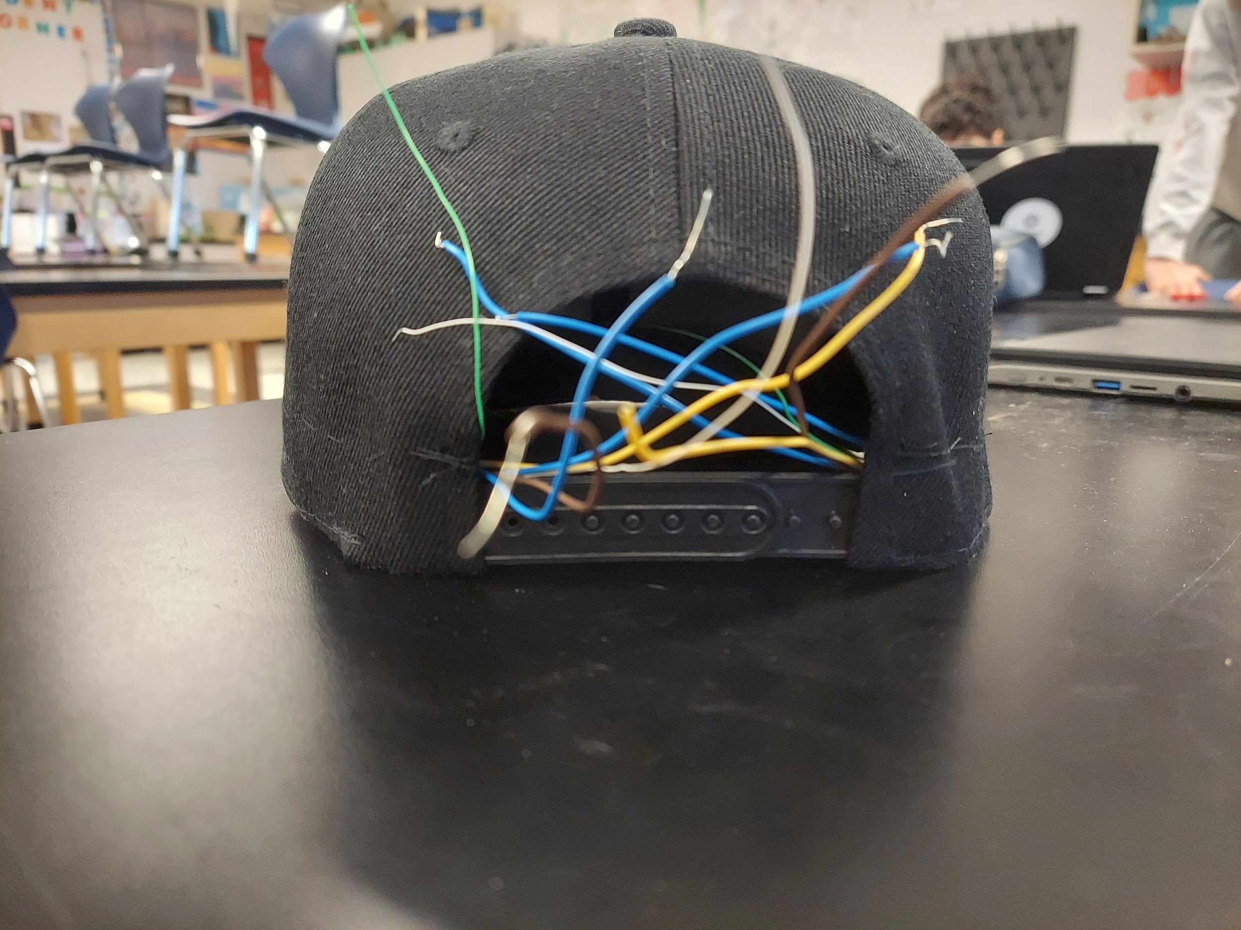



Next Meeting’s Agenda

## **2 February 2023 / Meeting Duration: 90 min, 7:00 - 8:30 AM**

ATTENDEES:

| Aadi | Adam | Arham | Grace | Hiranya | Pranathi | Rehaan | Sireesha |
| --- | --- | --- | --- | --- | --- | --- | --- |
| ✅ |  | ✅ |  | ✅ | ✅ | ✅ | ✅ |

AGENDA

* Upload updated code to arduino
* Continue testing
* Continue to work on website
* Continue to work on ultrasonic sensor enclosures

# Work Accomplished

* Finished designing enclosures
  + Will edit/revise/improve design
  + Found two enclosures online:
    - First one is a simple box that doesn’t have any mounting holes to connect to the hat:

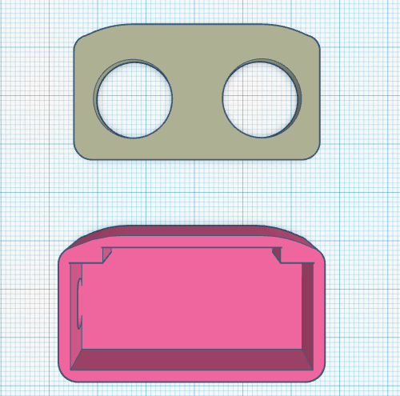

* + - The second enclosure has mounting holes but the enclosure angles the sensor oddly, which could hinder the accuracy of our device: 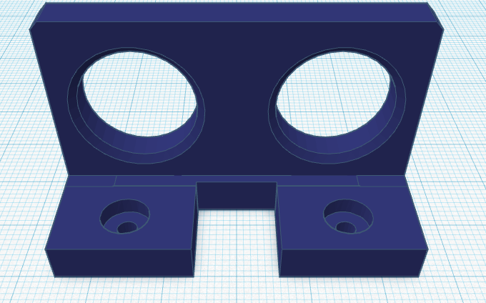
    - The third enclosure has a mount that seems to work well with our hat: 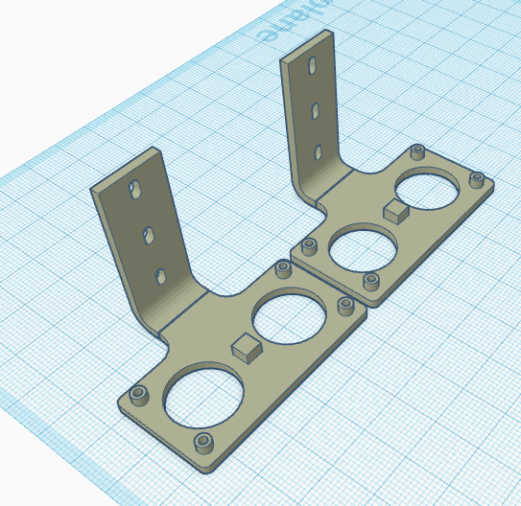

Next Meeting’s Agenda

## **26 January 2023 / Meeting Duration: 90 min, 7:00 - 8:30 AM**

ATTENDEES:

| Aadi | Adam | Arham | Grace | Hiranya | Pranathi | Rehaan | Sireesha |
| --- | --- | --- | --- | --- | --- | --- | --- |
| ✅ | ✅ | ✅ | ✅ | ✅ | ✅ | ✅ |  |

AGENDA

* Started to CAD enclosures for ultrasonic sensors
* Draft email to Omar for when we are done with the hat

# **Work Accomplished**

* Started to design enclosures for ultrasonic sensors
* Had to change ultrasonic sensor after resistor came off
* Changed code to increase range for when vibration motors will vibrate
  + Will vibrate when object is 90 cm away
* Update on Plus
  + Teachers will reach out to Project Invent for guidance, so we won't be doing anything for right now
* Draft to Omar

Hello Omar,

I hope you are doing well.

We just wanted to check in, as we have finished our second prototype. We have implemented your feedback from last time and made it less bulky, so we would really appreciate it if you would be able to test this version.

This time, we would like some of our team members to be able to come help with testing it in person as well. Would that work for you? If so, where and when would you like to meet?

Thank you!

Best,

Pranathi Ravipati

Team Overhead

* Draft of Hack+ email for future (email **jamsheed@hackplus.io**):

Hello from the Overhead Initiative Team!

We are a student lead team of high school innovators that have been working on a community project for the past year (September, 2021 - Present) with a goal of empowering the visually impaired. In the process, we have developed several working iterations of a prototype invention for the purpose of aiding the visually impaired in detecting overhead obstacles. We believe that Hack+ backing would serve as the catalyst needed to set the stage for success in our future endeavors. The aid of Hack+ would help us expand our community outreach by supporting us in launching a registered nonprofit, which would provide us with greater credibility and support our funding by helping us gain a stable banking infrastructure. We would greatly appreciate your assistance if you could guide us through the process or connect us to the right people.

Thank you for your time.

Best,

Overhead Initiative Team

* Continued working on About Us page
* Worked on resoldering hat using flux, sewing the battery holder for testing, and got everything working
* Need to change code to 30-90 cm
* Got some testing done, connections are solid and software is working
* Possible showcase opportunities?
* Continue working on finishing up website
* Start to market ourselves and garner attention from outside parties (Through Instgram, Website,ie.)
* Research on hackplus.io on the legal process that goes with being a non profit.

Next Meeting’s Agenda

* Finish hat/hat testing
* Continue to work on website
* If we finish, send email to Omar

## **21 January 2023 / Meeting Duration: 90 min, 10:00 - 12:30 AM**

ATTENDEES:

| Aadi | Adam | Arham | Grace | Hiranya | Pranathi | Rehaan | Sireesha |
| --- | --- | --- | --- | --- | --- | --- | --- |
| ✅ | ✅ | ✅ | ✅ | ✅ | ✅ | ✅ | ✅ |

AGENDA

* Solder the nano and battery
* Try to talk to teacher about hackplus.io + research for NPO
* Further test our new prototype
* Try to reach out to Omar and have him test prototype

# **Work Accomplished**

* Finished Soldering
* Tested new prototype and fixed small software issues
* Worked on non profit website
  + Finished most of ‘About Us’ page
* Discussed hackplus.io with Ms. Spector
  + Will email Project Invent for guidance
* Learned more about hackplus.io

Next Meeting’s Agenda

* Continue to work on the website
* Create possible posts for Instagram account
* Continue on the GoFundMe post?
* Try to meet with Omar before February break
* Test Prototype
* Resolder sensors that have fallen out of place
* Research in-depth about npo status
* Update Omar about prototype

## 

## **19 January 2023 / Meeting Duration: 90 min, 7:00 - 8:30 AM**

ATTENDEES:

| Aadi | Adam | Arham | Grace | Hiranya | Pranathi | Rehaan | Sireesha |
| --- | --- | --- | --- | --- | --- | --- | --- |
|  |  | ✅ | ✅ | ✅ | ✅ | ✅ | ✅ |

AGENDA

* Continue to work on prototype
* Research NPO status possibility

# **Work Accomplished**

* Finished stitching hat
  + Will work on soldering next time

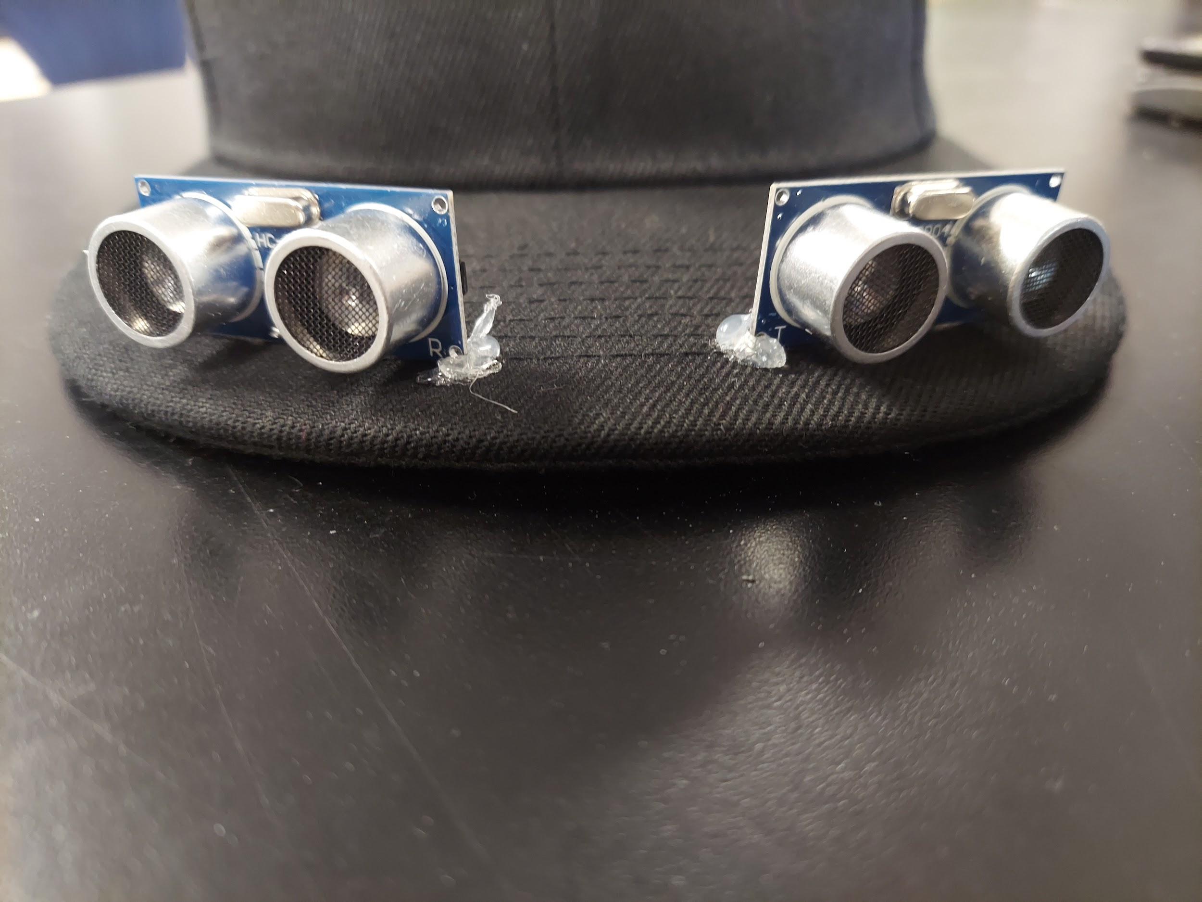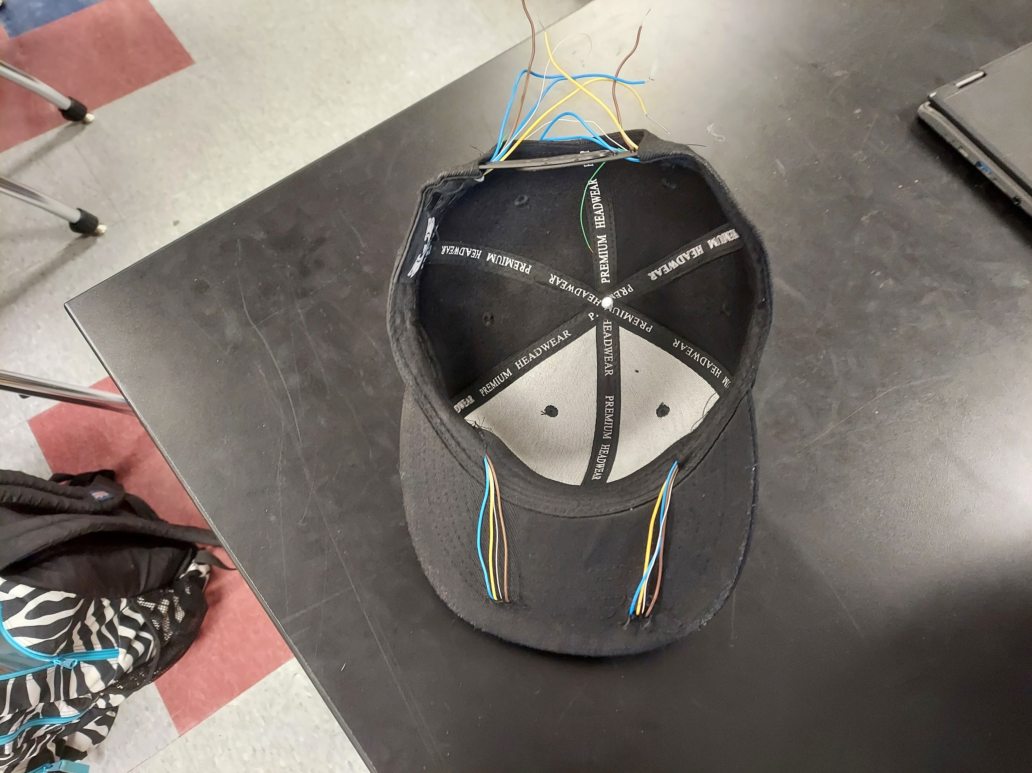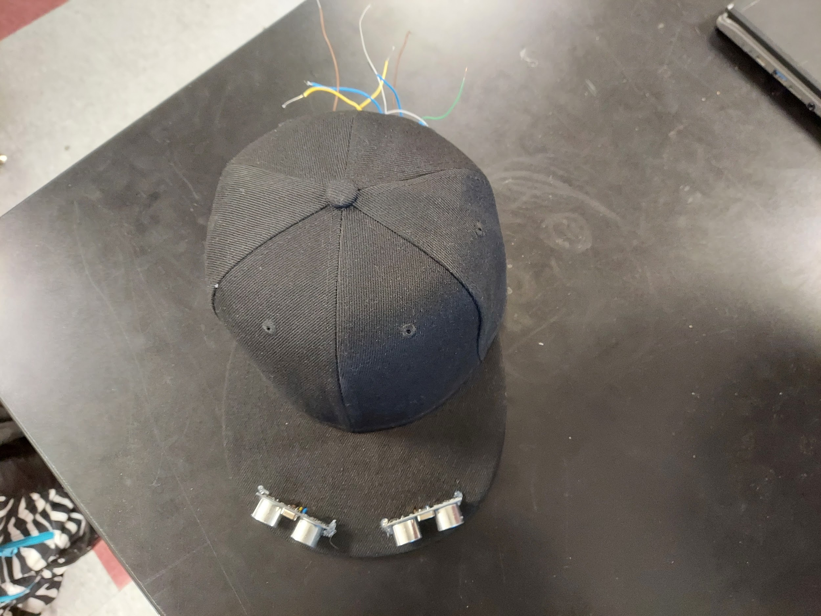

* Researched NPO
  + Website: [hackplus.io](https://hackplus.io/)
  + Seems reliable

Next Meeting’s Agenda

* Continue to solder
* Start pursuing NPO status through hack plus and/or consult teachers for more info & additional opinions if necessary

## **12 January 2023 / Meeting Duration: 90 min, 7:00 - 8:30 AM**

ATTENDEES:

| Aadi | Adam | Arham | Grace | Hiranya | Pranathi | Rehaan | Sireesha |
| --- | --- | --- | --- | --- | --- | --- | --- |
|  | ✅ | ✅ | ✅ | ✅ | ✅ | ✅ |  |

AGENDA

* Continue to solder
* Check if there is another business milestone to complete

# Work Accomplished

* Continued to solder
  + Hope to finish/be close to finishing
* If we finish the hat we will update the website with pictures
* Stitching the vibration motors and the nano to the hat
  + Then we will solder them to the PC board
* Will try to finish sewing today and then finish soldering next time

Next Meeting’s Agenda

* Continue to solder
* Hope to finish/be close to finishing

## **7 January 2023 / Meeting Duration: 150 min, 10:00 - 12:30 PM**

ATTENDEES:

| Aadi | Adam | Arham | Grace | Hiranya | Pranathi | Rehaan | Sireesha |
| --- | --- | --- | --- | --- | --- | --- | --- |
| ✅ | ✅ | ✅ | ✅ | ✅ | ✅ | ✅ | ✅ |

AGENDA

* Resolder hat
* Continue to work on website

Work Accomplished

* Used nail and hammer to make 8 evenly spaced holes near the front of the bill of the hat for the wires to connect to each ultrasonic sensor
  + Then connected the holes for wires to go through hat using knife

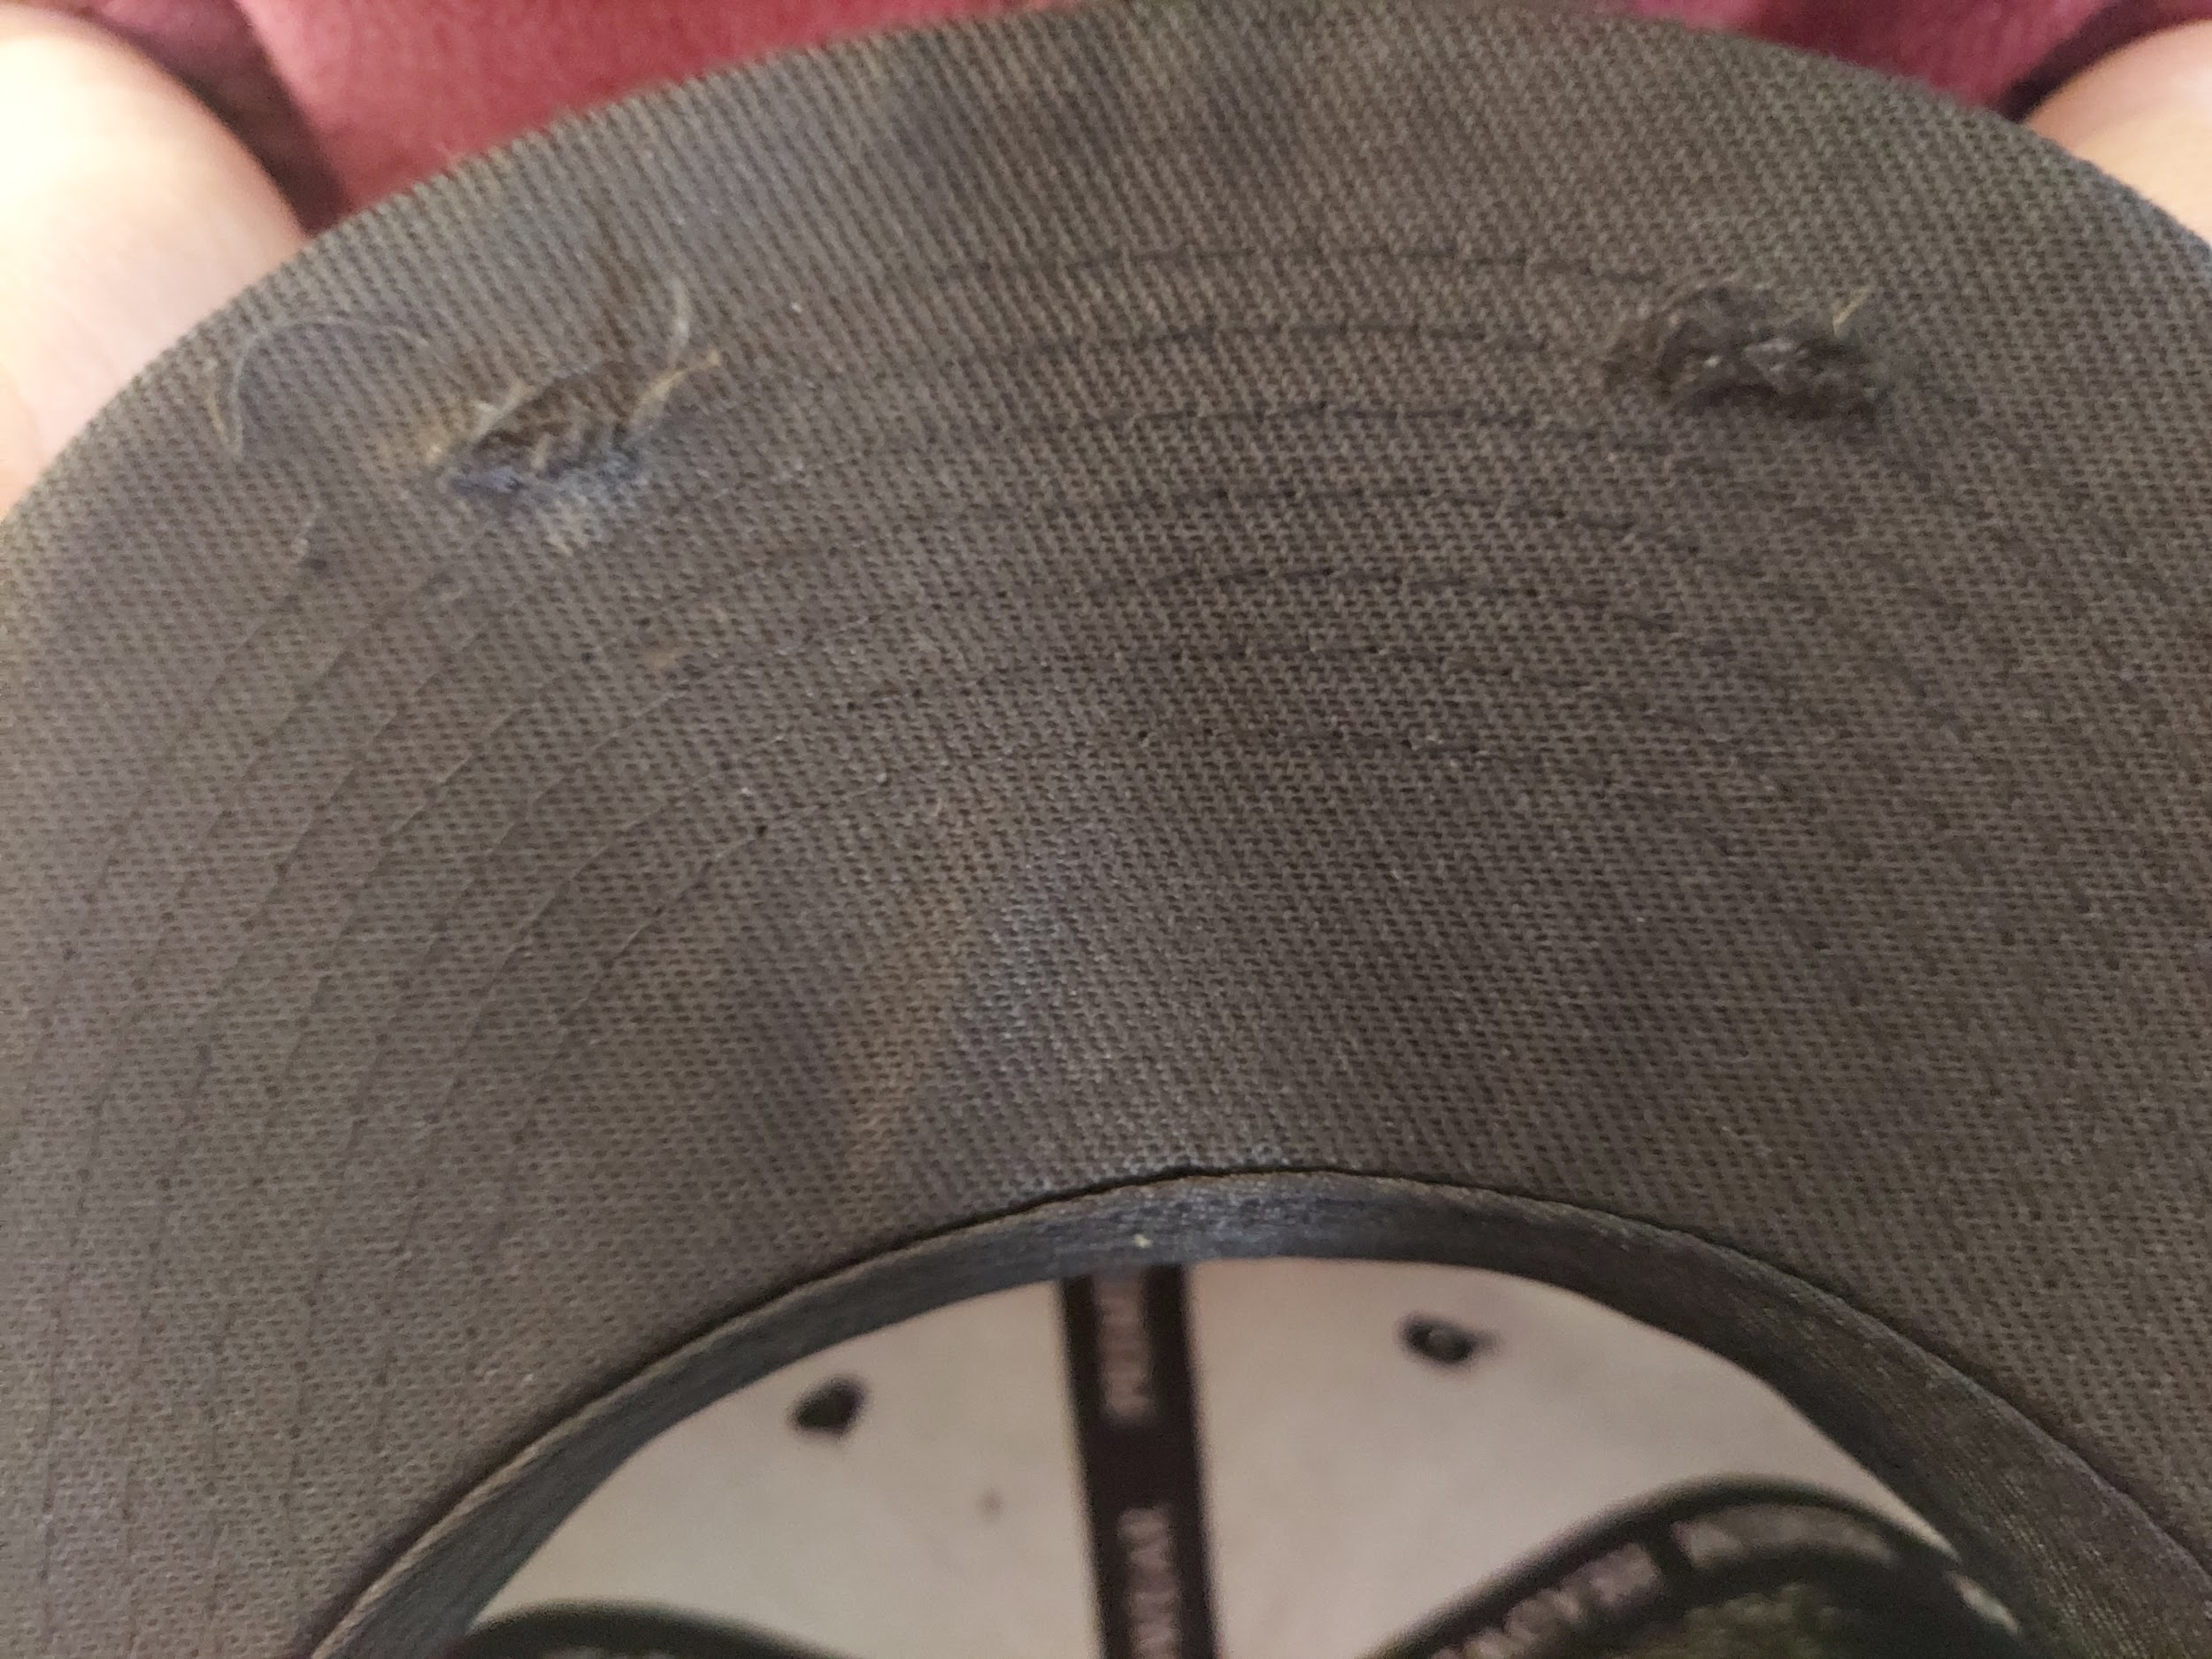

* Cut wires based on measurements
  + Eight 16-inch wires
  + Four 10-inch wires
* Were able to solder the wires to one ultrasonic sensor
* Going to meet on Thursday to try and finish soldering

Next Meeting’s Agenda

* Continue to work on website
* Continue to work on hat

## 

## **2 January 2023 / Meeting Duration: 210 min, 9:00 - 12:30 PM**

ATTENDEES:

| Aadi | Adam | Arham | Grace | Hiranya | Pranathi | Rehaan | Sireesha |
| --- | --- | --- | --- | --- | --- | --- | --- |
| ✅ | ✅ |  | ✅ | ✅ | ✅ | ✅ |  |

AGENDA

Work Accomplished

* Created Instagram Account/Profile [needs posts]
* Created Website [needs information] (unpublished)
* Created GoFundMe [needs more info] (unpublished)
* Created diagram and took measurements for wires
  + Eight 16-inch wires for the sensors
  + Four 10-inch wires for the motors
  + We will not be using the proto board anymore
    - Instead we will be making wire harnesses
      * We are stacking 4 ground connections and 3 power connections on top of each other

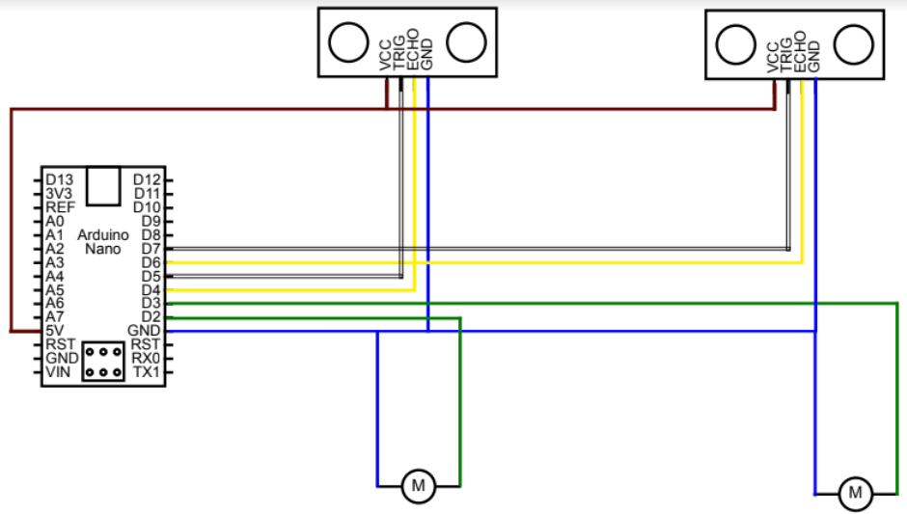

Next Meeting’s Agenda

* Resolder hat
* Continue to work on website

## 

## **7 December 2022 / Meeting Duration: 90 min, 7:00 - 8:30 AM**

ATTENDEES:

| Aadi | Adam | Arham | Grace | Hiranya | Pranathi | Rehaan | Sireesha |
| --- | --- | --- | --- | --- | --- | --- | --- |
| ✅ | ✅ | ✅ | ✅ | ✅ | ✅ | ✅ |  |

AGENDA

* Learn how to solder
* Check if hat came
* Start website

# Work Accomplished

* Checked if hat came
  + Hat comes tomorrow
  + Will pick it up during lunch to take home to work on during break
* Did soldering practice
* Learned how to solder
* Soldered first cricuit to 9V Battery
* Reviewed agenda and plan to follow during break
  + Planning for at least one in person meeting
* Learned how to solder
  + Soldered multiple wires together
  + Soldered circuit to 9V Battery
    - Worked for a moment! (even if the bulb burned out a moment later)
  + Plan to meet during break
  + So we can do soldering on the hat over break
* Created business email to use wix for website

Next Meeting’s Agenda

* Pick up hat
* Start working on soldering for hat (fix measurements)

## 

## **3 December 2022 / Meeting Duration: 270 min, 8:00 AM - 12:30 PM**

| Aadi | Adam | Arham | Grace | Hiranya | Pranathi | Rehaan | Sireesha |
| --- | --- | --- | --- | --- | --- | --- | --- |
| ✅ | ✅ |  | ✅ |  | ✅ |  | ✅ |

AGENDA

* Figure out fundraising (patent, licensing)
* Work on prototype
* Talk about website + social media account

# Work Accomplished

* Update: Bought black cap for $12.99
  + Should come next week
  + Possibly reach out to companies and either
    - ask for samples
    - ask to bulk buy at a discounted price
    - ~~ask them to discount their product line~~ (not viable)
* Fundraising options:
  + School fundraiser (solicitation of food)
  + Crowdsourcing (publicize)
  + Sponsor from company?
* Step-by-step process (first start with crowdsourcing, move onto to next viable option)
  + Options for crowdfunding
    - Project website donations
    - Other company website donations? (Buy Me A Coffee)
    - Through social media?
* Patent/Licensing options (open source [restrictions, “copy-left,” permissive?] Provisional? Etc.)
* Website? (Wix, WordPress, Google Sites, Coded or Drag & Drop Design)
  + Information on website?
    - [Information for PI Website](https://docs.google.com/document/d/1QTAx6lV1zN6LvxjhewxfIn9sssQ_muQyXkwSufJpWxY/edit?usp=sharing)

1. Problem inspiring project
2. Project Goal
3. Description

What we are using money for: materials, trademark/licensing

Fundraiser Plan:

1. Start with simple fundraiser - crowdsourcing from family and friends, use it as a backup source of compensation
2. Work on main source of compensation - club/school fairs + sponsors
3. Set up website + social media account for donations + promotion
4. Set up goal to reach considering costs for materials, licensing/trademark ($500)

Hardware Update:

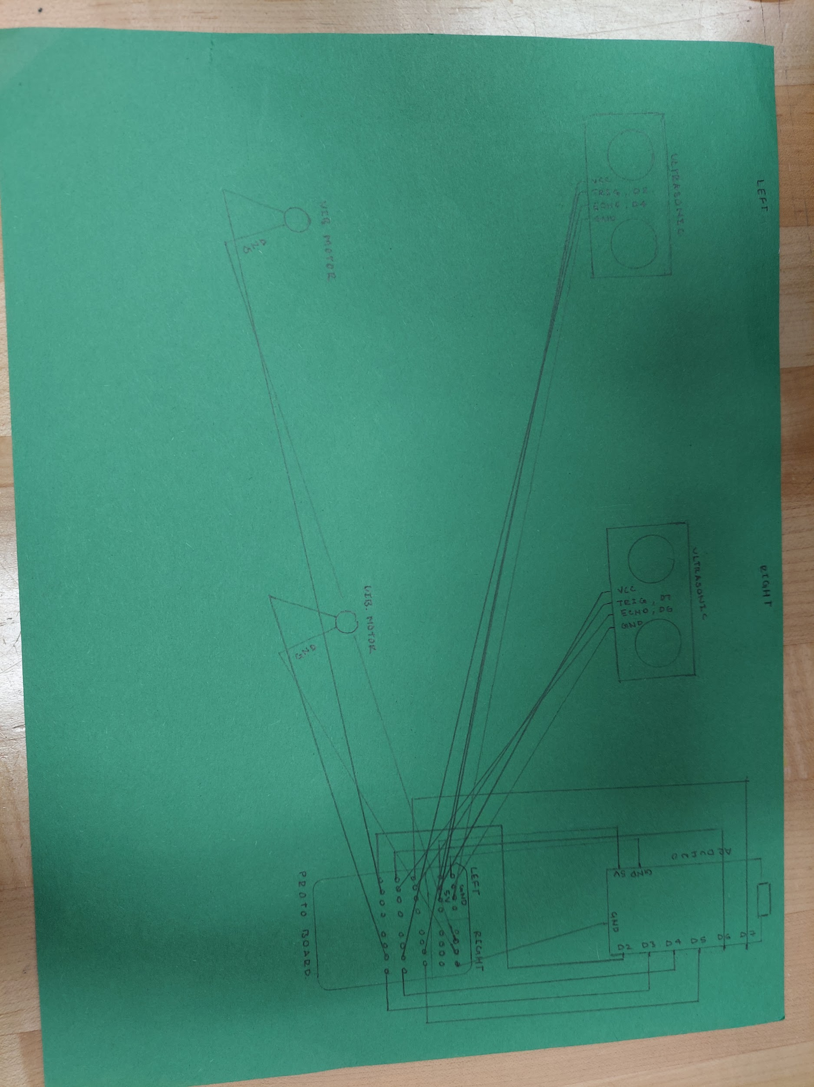

Current Blueprint of our prototype:

Current Goals:

* Reworking the prototype from last year to make it smaller and more unified.
  + Code and Hardware
* Locating superior/new materials
  + Research
  + Plan to use to NANO Arduino which is a faster and more compact.
  + It will fit on a breadboard since it doesn't have the same erratic pin spacing as other Arduino designs. This has definite benefits.
* Possibly discuss and think about different adaptation of our product (e.g. Headbands)

Next Meeting’s Agenda

* Work on a fundraising plan (how to fundraise money, how much, what do we need it for?)
* Work on prototype (wait for hat to come, install hardware, run tests)
* Send email to Ms. Spector about reminder for patent/licensing
* Look out for Project Invent Milestones

## **17 November 2022 / Meeting Duration: 90 min, 7:00 - 8:30 AM**

ATTENDEES:

| Aadi | Adam | Arham | Grace | Hiranya | Pranathi | Rehaan | Sireesha |
| --- | --- | --- | --- | --- | --- | --- | --- |
| ✅ |  | ✅ | ✅ | ✅ | ✅ | ✅ |  |

AGENDA

* Continue to work on prototype

# Work Accomplished

* Drafted email to Ms. Toyama to order non-logo hat (will send after getting response from Omar)
  + [CHOK.LIDS Flat Bill Visor Classic Snapback Hat Blank Adjustable Brim High Top End Trendy Color Style Plain Tone Baseball Cap](https://www.amazon.com/Flat-Visor-Snapback-Blank-Baseball/dp/B07521K5HP/ref=sr_1_1?crid=34NX1N98EWY9K&keywords=Flat+Brim+Hats+no+logo&qid=1667058470&qu=eyJxc2MiOiIwLjAwIiwicXNhIjoiMC4wMCIsInFzcCI6IjAuMDAifQ%3D%3D&sprefix=flat+brim+hats+no+logo%2Caps%2C162&sr=8-1)
    - $12.99-14.99 depending on color
    - Decided to get one non-logo hat instead of the 6-pack of hats with logos
* Sent email to Omar
  + Asked about preferred color of hat
* Found company with electronics that would help with wearable products ([LOOMIA Electronics](https://www.loomia.com/))
  + Flexible, soft wires
  + Expensive
    - Would need to fundraise or send email
* Planning to start making website
  + Information needed
    - Title
    - Mission/Goal/Description
    - Technical aspects
    - Images
* Additional Ultrasonic Sensors
  + Make sure that they can convert analog to digital
  + If they can’t convert, list below
  + Research how to convert

Next Meeting’s Agenda

* Work on product
* Research materials

## **7 November 2022 / Meeting Duration: 90 min, 7:00 - 8:30 AM**

ATTENDEES:

| Aadi | Adam | Arham | Grace | Hiranya | Pranathi | Rehaan | Sireesha |
| --- | --- | --- | --- | --- | --- | --- | --- |
| ✅ | ✅ | ✅ |  | ✅ | ✅ |  | ✅ |

AGENDA

* Project Invent Journal
* Edit and present proposal (receive feedback)

# Work Accomplished

* Feedback/Notes for Other Teams (on Year 2 Journal)
* Presented proposal

Next Meeting’s Agenda

* Work on product
* Research materials

## **11/07/22 Actionable Feedback on Presentations**

## Bien: Food bank conveyer belt (previously SLAM)

* Could explain more about flowcharts/sketches and explain how they represent his project
* Could delve a little deeper into what constitutes project development
* Will you be conducting an interview or observing at the food bank?

Romina (Elevate): STEM in Underrepresented Communities

* Make more of a distinction between who exactly are the type of people that they are focusing on.
* Would the same curriculum be used for the whole classroom or would it be modified/personalized for each student based on their needs?

Anika (CARE): Watch to help with panic attacks

* A bit broad in analysis of previous process, in making the product.
* Have you already created the app mentioned in your slides or are you currently working on it?

Ethan (Tutelage): Teaching Pomeroy students STEM

* How will you test the curriculum? Who exactly are you planning to test it with?
* Some of the graphics related to the slides are distracting or nonexistent, which makes it hard to refocus directly on the topic if one’s attention is whisked away for a moment.

Aidan (REPS): to increase awareness of native plant species

* How would you go about your distribution process and your marketing?
* Is there a specific target audience who would benefit/be interested in the project?
  + Beyond biologists in general
* How do you plan to go about funding your project? What goals do you have in place for funding?

Joel (NPCs): Help seniors stay protected from cybercrimes

* How would you go about distributing or sharing the contents of your project? How do you plan to garner public support and interest? How do you plan to attractBroad Description of goal and process
  + Could elaborate further on project goal beyond just senior citizens
  + What is your process for meeting with the seniors
* consumers/users?
* Do you know where you are going to go to meet the seniors?

Aasees (150 years project): Float

* Less project feedback - voice was somewhat difficult to hear, volume seems to trail off towards the end of a sentence.
* Future steps appear to be somewhat generic; could discuss specific ways that your team will make an impact on the SCHS community
* Will you be doing any projects during junior year, or is this year just for planning?

## Rianna (pick-me-up): Guitar help

* Have you reached out to other organizations or entities that could assist in your project
* Will they be conducting empathy interviews?

Devin (RE-ACT): Create lasting recycling system at SCHS

* How will the system be enforced regarding students?
* How will you be effective in appealing to students? How might you convince them to engage with your project and actively utilize it?

Lauren (STEAM): Video series to educate about STEM

* How will these videos be distributed/shown to students?
* How will you appeal to students and convince them to engage with the videos you create? How might you create these videos in a way that they are impactful for viewers?

## 

## **11/01/22 Reflections A) How many hours did you (yourself) spend on the project? B) What exactly did you accomplish? Specifically, what tasks did you complete?**

**Adam**: Since October 20th I have spent around 2-3 hours on the project itself. Throughout the year I have spent approximately 10-12 hours due to some missed meetings as a result of scheduling conflicts. When our team got finalized I was a new member and as a result I was unfamiliar with Team Overhead’s product. I spent a majority of my time learning our product and how it functions for me to be able to apply my own skills and learning into the project. As a member of the hardware division it is especially important that I know how each component of the product functions in order to be able to tweak, update, or even replicate the model of our product to showcase the engineering process that was done over the course of the year. Recently i started to learn about PCB and soldering which are two basic components regarding our products hardware design. In the last meeting we discussed how we are going to transfer our current model and revamp it into a smaller and sleeker design in order for it to be convenient for our users. As a prediction for the future, we should be able to have a completely functional and working design with schematics of both the hardware and software components to be sent out for possible investors.

**Aadi**: Since October 20th, I have spent 2 hours on the project. Throughout the year, I have completed 12 hours. In the beginning, I helped plan out our project goals and roles. I then primarily worked on the DVF Analysis, which required us to evaluate the desirability, viability, and feasibility of our product and discuss how we would improve these three key aspects of our product as the prototype evolved over time. Recently, I spent quite a bit of time researching materials for future iterations of our prototype, including ultrasonic sensors, one of which had specifications that matched up well with our design (albeit with some difficulties). In addition, our prototype design needs various improvements, especially in terms of the size of specific parts and the visibility of the electronics, so we discussed different changes we could make to the design, including whether or not we should make a custom PCB. In the last meeting, I (and a few others from our team) conversed to learn more about possible design changes and whether we would need the milling machine in preparation for the creation of future iterations of our prototype.

**Sireesha**: Since October 20th, I have spent 2 hours on the project. Throughout the year, I have completed 12 hours. The two major tasks I worked on were the Business Canvas Model and the DVF Analysis, The Business Canvas Model essentially highlights our business plan for the year and how we will continue to improve our product. Our DVF allowed us to see if our product would be able to serve a large community in the future, even with our community partner having specific needs. I worked with Pranathi on the first and final draft, along with editing them with the comments Ms. Spector made. I then went on to do research on the new materials we will need for our hat, producing satisfactory results that kept in mind our current limitations. I was able to find a manufacturer that produces different types of ultrasonic distance and proximity sensors that would help increase our options as a team.

**Grace**: Since October 20th, I have spent 3 hours on the project. Throughout the year, I have completed about 16 hours. I worked on planning out our project goals, doing tests and fixing prototype 1, as well as beginning prototype 2 with the arduino nano. I also helped start trying to figure out the milling machine we have in the lab.

**Pranathi**: Since the last submission on October 20th, I have spent 2 hours on the project. Since the beginning of the year, I have completed 14 hours and 30 minutes. I worked on the milestones that we were given for Project Invent. Specifically, I helped complete the DVF Analysis, which was used to evaluate the desirability, viability, and feasibility of our project. This assignment has now been completed. We also received feedback from our previous milestone assignment, the Business Canvas Model. Using those comments from Ms. Spector, I helped revise the assignment and we resubmitted it. Most recently, I helped with researching new materials for our improved project. This included smaller ultrasonic sensors and flat brim hats. Our ideal hat is one without a logo, but we decided that we can use those for our final product. However, we are thinking of buying a 6-pack of flat brim hats for prototypes. We researched while keeping the prices and our budget in mind.

## **29 October 2022 / Meeting Duration: 120 min, 8:30-10:30am**

ATTENDEES:

| Aadi | Adam | Arham | Grace | Hiranya | Pranathi | Rehaan | Sireesha |
| --- | --- | --- | --- | --- | --- | --- | --- |
| ✅ | ✅ | ✅ | ✅ | ✅ | ✅ | ✅ | ✅ |

AGENDA

* Fix prototype (figure out root issue)
* Refine business model canvas
* Research materials

# Work Accomplished

* Finished BMC
  + Answered and improved all questions
* Worked on the prototype
* Looked and refined comments on business model canvas
* Looked for new prototyping materials
  + [MANUFACTURERS BY PRODUCT CATEGORY](https://www.mouser.com/manufacturer-category/) - for any electronic component
  + **Ultrasonic sensors**
    - Chirp Microsystems’ CH-101 and CH-201  
      [World’s Smallest, Lowest-Power Ultrasonic Time-Of-Flight Sensors](https://www.eeworldonline.com/worlds-smallest-lowest-power-ultrasonic-time-of-flight-sensors/)
    - CH-201  
      [CH201-00ABR MEMS Ultrasonic Time-of-Flight from TDK InvenSense](https://www.cdiweb.com/products/detail/ch20100abr-tdk-invensense/672928/?utm_source=netcomponents&utm_medium=inventory-feed&utm_campaign=buy-now-netcomponents&pid=2265)
      * Price: 1 - 99 (quantity) → $9.16 per unit
      * Range: 20 cm to 5 meters
      * Sample rate: up to 100 samples/min
      * More specifications: https://www.mouser.com/catalog/specsheets/TDK_10012020_DS-000379-CH201-v1.1.pdf
      * 3.5 x 3.5 x 1.26 (mm)
      * Fast, accurate range-finding
      * Multi-object detection
      * CH-201 can be bought from:  
        <http://dilp.netcomponents.com/cgi-bin/tdkcorp.asp?mode=1&partnumber1=CH201&partnumber2=&partnumber3=&pq=Search>
    - [HiLetgo 20pcs TCT40-16R/T 16mm Split Ultrasonic Sensor Ultrasonic Transceiver Probe 10 Transmitters + 10 Receivers T+R Ultrasonic Sensor Set](https://www.amazon.com/HiLetgo-Ultrasonic-Sensor-Transceiver-Receiver/dp/B00M2GHG66/ref=cm_cr_arp_d_pl_foot_top?ie=UTF8)
      * Price: 10 T. + 10 R. (quantity) $9.49 in total
      * 74% five stars and 17% four stars (36 reviews)
        + 4.6 overall
      * Weight: 0.634 ounces
      * Dimensions: ‎5.4 x 1 x 0.4 (in)
      * Range not listed
      * Sample rate not listed
      * Split Transceiver / Receiver
        + 10 transmitters + 10 receivers
    - [Mouser Electronics Ultrasonic Sensor](https://www.mouser.com/c/?q=ultrasonic%20sensor&rohscompliant=y):
      * - place to buy ultrasonic sensors
      * Proximity and distance sensors available
      * Sensible pricing (1 sensor - $16)
      * Good shipping time
      * Versatile options
    - Legitimate business
  + **Cheap flat-brim hats**
    - Final Product: [CHOK.LIDS Flat Bill Visor Classic Snapback Hat Blank Adjustable Brim High Top End Trendy Color Style Plain Tone Baseball Cap](https://www.amazon.com/Flat-Visor-Snapback-Blank-Baseball/dp/B07521K5HP/ref=sr_1_1?crid=34NX1N98EWY9K&keywords=Flat+Brim+Hats+no+logo&qid=1667058470&qu=eyJxc2MiOiIwLjAwIiwicXNhIjoiMC4wMCIsInFzcCI6IjAuMDAifQ%3D%3D&sprefix=flat+brim+hats+no+logo%2Caps%2C162&sr=8-1)
      * 73% five stars, 14% four stars
      * Flat brim, no logo
      * Cheap (12.99)
      * Package Dimensions: 10 x 9 x 7 inches; 8 Ounces
      * Fits most people
      * #11 in men’s baseball caps
    - [elante Plain Blank Flat Brim Adjustable Snapback Baseball Caps LOT 6 Pack](https://www.amazon.com/Gelante-Plain-Adjustable-Snapback-Baseball/dp/B07VD9CN1S/ref=sr_1_2?crid=234GTHE8Z7TW0&keywords=6+pack+flat+bill+hats&qid=1667059145&qu=eyJxc2MiOiIxLjQ0IiwicXNhIjoiMC4wMCIsInFzcCI6IjAuMDAifQ%3D%3D&sprefix=6+pack+flat+bill+hat%2Caps%2C178&sr=8-2)
      * 6 pack
      * $20.99
      * Has logo
      * 72% five stars, 12% four stars
      * Adjustable Plastic Snapback Closure
      * One Size fits Most Head Sizes
      * No dimensions available
    - [Falari Wholesale 12 Pack Snapback Hat Cap Hip Hop Style Flat Bill Blank Solid Color Adjustable Size](https://www.amazon.com/Falari-Wholesale-Snapback-Adjustable-G212-Assorted1/dp/B07FMHX9DV/ref=sr_1_8?crid=1I5LFGJ80QIO7&keywords=multiple+flat+bill+hats&qid=1667059133&qu=eyJxc2MiOiIxLjQyIiwicXNhIjoiMC4wMCIsInFzcCI6IjAuMDAifQ%3D%3D&s=apparel&sprefix=multiple+flat+bill+hats%2Cfashion%2C168&sr=1-8)
      * 12 pack
      * Price: $37.99
      * Does have some type of logo- a sticker or embroidery (can use for prototypes)
      * 75% five stars and 13% four stars (2,051 reviews)
      * Dimensions: 12.28 x 11.1 x 7.28 inches; 2.07 Pounds
      * Plastic Adjustable Snapback Closure, One Size fits Most Head Sizes
    - Idea
      * wire wrap wire - create wiring harness from the sensors and the board - no separate breadboard/pcb
        + possible create circuit board?

How to Use:[How to use the Roland monoFab SRM-20 Milling Cnc](https://www.youtube.com/watch?v=rFRuc0VPWDM)

Schematic Necessary and Software

The machine looks functional, but have not run any design.

Gerber file?

* + - * + CAD Enclosure for wires that allow direct connection to heat.
        + electrical interface

Next Meeting’s Agenda

* Continue to work on the cap
* Do more research for ordering materials
* Work on the next milestone if it is posted

**27 October 2022 / Meeting Duration: 90 min, 7:30 - 9:00 AM**

ATTENDEES:

| Aadi | Adam | Arham | Grace | Hiranya | Pranathi | Rehaan | Sireesha |
| --- | --- | --- | --- | --- | --- | --- | --- |
|  |  | ✅ |  | ✅ |  | ✅ |  |

AGENDA

* Project Invent Journal
* Work out software issues
* Working on the project CAD to make sure that all the measurements are planned and to make sure that we don't mess up.

## 

## **20 October 2022 / Meeting Duration: 90 min, 7-8:30**

ATTENDEES:

| Aadi | Adam | Arham | Grace | Hiranya | Pranathi | Rehaan | Sireesha |
| --- | --- | --- | --- | --- | --- | --- | --- |
| ✅ |  | ✅ | ✅ | ✅ | ✅ | ✅ | ✅ |

AGENDA

* Work on DVF Analysis
* Fix prototype (figure out root issue)
* Contact Omar for interview
* Refine business model canvas

# Work Accomplished

* Finished DVF
  + Answered all questions
* Figured out issue with the prototype
* Worked on contacting Omar (questions + email)
* Looked and refined comments on business model canvas

Next Meeting’s Agenda

* Finish working on Business Model Canvas second draft based on feedback
* Continue to work on cap

**9 October 2022 / Meeting Duration: 60 min, 1:30-2:30**

ATTENDEES: Sireesha, Pranathi

AGENDA

* Edit + finish proposal slides

# Work Accomplished

* Finished proposal slides
  + Added images and edited content
* Practiced presentation to get it under 2 minutes

Next Meeting’s Agenda

* Milestone 2 (DVF Analysis)

## 

## **6 October 2022 / Meeting Duration: 90 min, 7-8:30 am**

ATTENDEES: Rehaan, Arham, Hiranya

AGENDA

* Fix Circuitry
* Figure out Code Issue

# Work Accomplished

* Soldered Wires
* Tested code, but nothing was wrong on the simulator

# Next Meeting’s Agenda

* DVF Activity

## 

## **29 September 2022 / Meeting Duration: 60 min, 10-11:00 pm**

ATTENDEES: Sireesha, Pranathi

AGENDA

* Team Business Model

# Work Accomplished

* Worked on and finished boxed answers for page 3 and page 4
  + Skipped 6b on page 4 & 8/9 on page 5 for now
* Started working on page 5

NEXT MEETING’S AGENDA

* Turn in the business model on Friday (10/7)

## 

## **29 September 2022 / Meeting Duration: 90 min, 7-8:30**

ATTENDEES: Arham and Hiranya

AGENDA

* Team Business Model

# Work Accomplished

* Made significant changes to business model
* Converted to Canva: [Overhead Team Business Model](https://www.canva.com/design/DAFNnqWnPno/WwVx798-DEDXfDgqT1ndWQ/edit?utm_content=DAFNnqWnPno&utm_campaign=designshare&utm_medium=link2&utm_source=sharebutton)

NEXT MEETING’S AGENDA

* Review Model
* Fix Issues with Right Ultrasonic Sensor

## **24 September 2022 / Meeting Duration: 90 min, 7-8:30**

ATTENDEES: Arham and Hiranya

AGENDA

* Work on software
* Make sure both sensors work perfectly

# Work Accomplished

* Updated software to Arduino
* Resoldered right-side ultrasonic sensor
* Left-side sensor + software working perfectly
* Right-side sensor not working

NEXT MEETING’S AGENDA

* Try to understand why right-side doesn't work
* Work on business model
* Finish any deliverables due for our subteam (software/hardware)

## 

## **22 September 2022 / Meeting Duration: 90 min 7-8:30**

ATTENDEES:

* All here except Aadi (sick) and Adam (absent)

AGENDA

* Work on Business Model Canvas draft
* Rework prototype - work on code and product

# Work Accomplished

* Code updated: [Code Backup](https://docs.google.com/document/d/1CkjZluxT2sZEcVpjfbYDCYHYLEyJnrkTf8XQkRYepeQ/edit?usp=sharing)
* Filled out value proposition and customer relationships on Business Model Canvas
* Watched required videos for Business Model Canvas

NEXT MEETING’S AGENDA

* Finish final draft of business model canvas
* Start october proposal
* Refine code and rebuild product

## 

## **12 September 2022 / Meeting Duration: 90 min**

ATTENDEES:

* All here

AGENDA

* Define group roles
* Write team on whiteboard
* Continue discussion on saturday (product design/model, different aspects of roles)
* Start working on presentation for October

# Work Accomplished

* Group Roles successfully assigned
  + Hardware:
    - Grace (leader/manager)
    - Hiranya
    - Adam
  + Software:
    - Arham
    - Rehaan
    - Aadi
  + Outreach/marketing
    - Sireesha (journal manager)
    - Pranathi
    - Adam
    - Nohami
    - Aadi
* Current outreach tasks:
  + Work on October proposal
    - Due 10/9, presenting on 10/10
  + Business Model Canvas
    - Draft due 9/22
    - Final due 9/30
* Hardware/Software
  + Creating custom PCB design and coding it:
    - [Tutorial #7: How to Write Software And Program Your Board - Step by Step](https://www.youtube.com/watch?v=e6YTg-UrKes)
    - PERF Boards: [Using Perfboard | Soldering Basics](https://www.youtube.com/watch?v=l9Kbr8cPqOE)
    - Similar Device: [Jacob Donnini Maker Portfolio](https://www.youtube.com/watch?v=v-nSR3PZT14)
  + Do ASAP, and convert file from Arduino language to whatever we need
* Business Model Canvas Draft Link
  + [Business Model Canvas Draft](https://docs.google.com/document/d/1vCFpP5bhvx6dxmFpD1huWvt1fWfdUtHB1PHICVzb_t0/edit?usp=sharing)

NEXT MEETING’S AGENDA

* Start working on the business model
* Start working on October proposal presentation
* Start working on plans for soft/hardware

## **10 September 2022 / Meeting Duration: 150 min (2 hr 30 min)**

ATTENDEES: all

Pranathi, Sireesha, Grace, Aadi, Hiranya, Arham, Rehaan, Adam

AGENDA

* Plan detailed next steps for product
* Brainstorm new design for product

# Work Accomplished

* Next steps:
  + Can’t be associated with brands/companies (new hat, no Arduino)
    - Maybe use microcontroller and relay
  + Vibration sensors sewed into seams of hat
  + Smaller ultrasonic sensors (can’t see them, lighter
    - Link:
  + Customized circuit board (maybe use the machine in the FabLab)
  + Later maybe work with cameras, machine learning instead of ultrasonic sensors
  + Use waterproof materials around the front and bottom of bill, waterproof ultrasonic sensors
  + With hat, have an inner layer (cardboard, other material) to build on top of, outer cloth (hat material) layer
  + Marketing, funding, patent, website (future)
  + Aspects: Engineering/Building, Outreach/Communication, Funding, Marketing, Business
  + Business model canvas (key partners, activities, problem we’re trying to solve, consumer relationship, price structure cost)
    - [How To Use The Business Model Canvas - A Complete Guide](https://www.garyfox.co/canvas-models/how-to-use-business-model-canvas-guide/)
  + Custom Circuits:
    - SRM-20 may be able to help users create compact-custom circuit boards for free
    - Received permission from Ms. Toyama to use the Roland SRM-20 machine in the fab lab
    - SRM-20 runs on Linux, but there might be PC support available
    - Before using the machine, we must have a compact circuit design in place.
    - We should learn the Roland SRM-20 software after doing so
    - Learn how to operate the UI on the physical machine
    - [How to use the Roland monoFab SRM-20 Milling Cnc](https://www.youtube.com/watch?v=rFRuc0VPWDM)
  + Website
    - Don’t use last names for community partner or us
    - Introduce community partner, problem, solution
    - Wix <https://www.garyfox.co/canvas-models/how-to-use-business-model-canvas-guide/>
  + Project Overhead Website Team Names
    - ideaoverhead
    - theoverheadteam
    - theprojectoverhead
    - overheadinitiative
    - missionoverhead
  + Password
    - ASASAHNZSDGCRKPRHP0!

# NEXT MEETING’S AGENDA

* Define team roles and responsibilities
  + Discuss goals for each group
* Start thinking about circuit design and overall design

## 

## **22 August 2022 / Meeting Duration: 90 min**

ATTENDEES

* **Sireesha, Pranathi, Grace, Adam, Aadi**

AGENDA

* Finalize teams
* Discuss when to meet
* Journal link set up/submission

# Work Accomplished

* Created Project Journal for our team
* Journal Link Submitted

# NEXT WEEK’S AGENDA

* Work on project invent product
* Discuss meeting times/schedules

Update: 9/5/2022

What we will improve:

* Durability - the hat’s ability to withstand different types of weather (mainly trying to make the hat waterproof by using waterproof sensors and other materials, might use 3D printer to make “cases” for the ultrasonic sensors)
* Functionality - the sensor’s ability to properly detect objects at a certain distance
* Comfort - the hat’s overall feel for the user (Omar asked for the sensors and wiring to be less visible or completely not visible)
* Price - make the hat in a way so we can sell it at a lower price (Accessibility to our target audience)
* Consistency - the hat’s ability to perform without any malfunction or for a long period of time

Timeline: 1st semester (Tentative, will check with Ms. Spector about dates for Extended Hours and next steps for the program)

August-September:

1. Defining - what aspects should be improved, what features should be focus on the most to improve

September-November:

1. Brainstorming - making models & community partner/mentor feedback

November-December:

Start of prototyping - testing and building different models, using different or new materials